8.77: a) The coefficient of friction, from either force or energy consideration, is 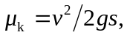where is the speed of the block after the bullet passes through. The speed of the block is determined from the momentum lost by the bullet, and so the coefficient of kinetic friction is

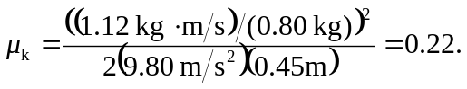

b) c) From the calculation of the momentum in part (a), the block’s initial kinetic energy was 